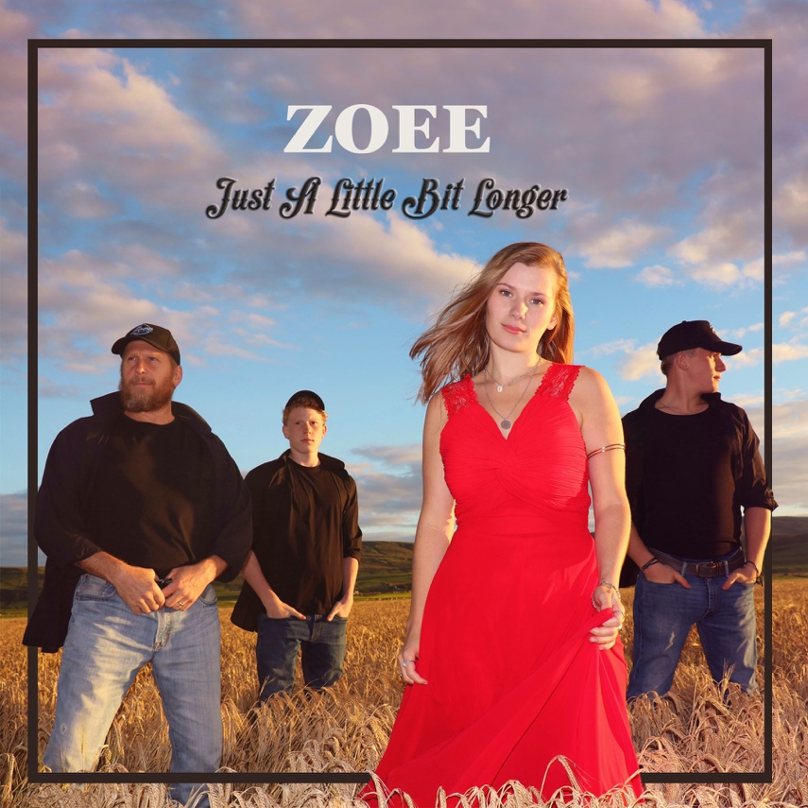
FOR IMMEDIATE RELEASE
April 1st, 2021.

Scottish-based singer-songwriter Zoee will release a new single “Just A Little Bit Longer” on April 16th, 2021.

The new single was recorded and mixed remotely in lockdown between Nashville and Scotland.

Zoee premiered a version of the song exclusively on BBC Bristol in December.

She says of the song, “It is a letter I wrote, to my future-self about holding onto the good times. It was inspired by the great Americana roots sound of the South that I was surrounded by when I wrote the song, back in 2010.”

Zoee has announced they have already filmed a music video for it, which will be premiered shortly.

You can pre-save the single here: https://bit.ly/2Pplc6m

Follow Zoee & The Band here:
http://www.Zoee.uk
http://www.Facebook.com/zoeeofficial
http://www.Instagram.com/zoeeofficial
http://www.Youtube.com/c/zoeeoffical

